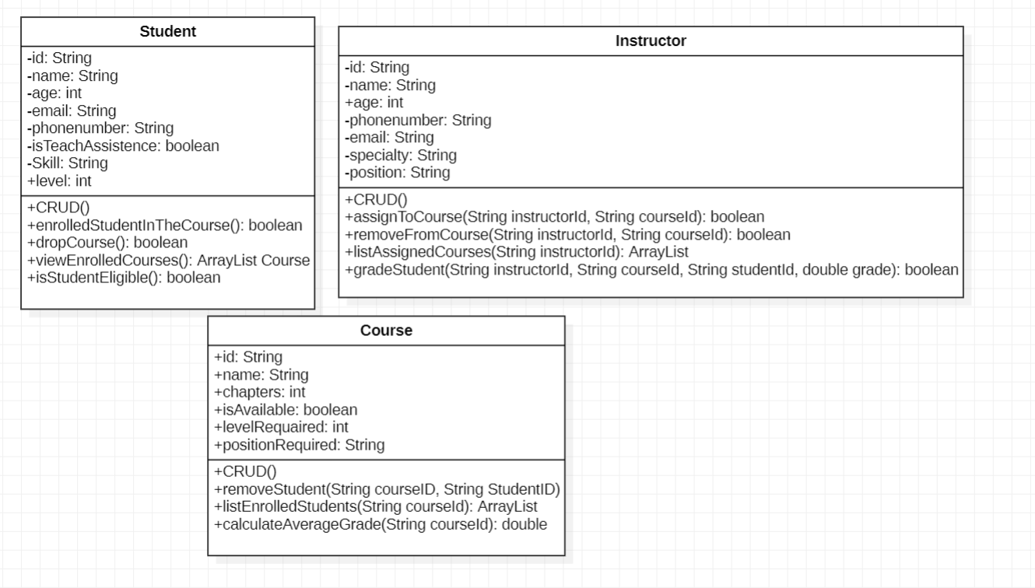

* id: unique identifier for the student.
* name: student's name.
* age: student's age.
* email: student's email address.
* phonenumber: student's phone number.
* isTeachAssistence: flag to check if student is a teaching assistant.
* Skill: the student's skill (like Java, AI, etc).
* level: level of the student (e.g. 1, 2, 3...).

**Methods:**

* CRUD(): basic Create, Read, Update, Delete operations for the student.
* enrolledStudentInTheCourse(): enroll the student into a course if eligible.
* dropCourse(): remove the student from a course they are enrolled in.
* viewEnrolledCourses(): returns a list of all courses the student is currently enrolled in.
* isStudentEligible(): checks if the student meets the requirements for enrollment in a course.

**Instructor Class:**

**Attributes:**

* id: unique identifier for the instructor.
* name: instructor's name.
* age: instructor's age.
* phonenumber: instructor's phone number.
* email: instructor's email address.
* specialty: instructor's area of expertise (e.g. Networking, AI).
* position: job position (e.g. Professor, Lecturer).

**Methods:**

* CRUD(): basic Create, Read, Update, Delete operations for the instructor.
* assignToCourse(instructorId, courseId): assign this instructor to teach a specific course.
* removeFromCourse(instructorId, courseId): remove this instructor from a course.
* listAssignedCourses(instructorId): returns a list of courses the instructor is assigned to.
* gradeStudent(instructorId, courseId, studentId, grade): assign a grade to a student for a specific course.

Course Class:

Attributes:

id: unique identifier for the course.

name: name of the course.

chapters: number of chapters in the course.

isAvailable: indicates whether the course is open for enrollment.

levelRequired: the required level a student must have to join.

positionRequired: required instructor position (e.g., must be "Professor").

Methods:

CRUD(): basic Create, Read, Update, Delete operations for the course.

removeStudent(courseId, studentId): remove a student from this course.

listEnrolledStudents(courseId): returns a list of all students currently enrolled in the course.

calculateAverageGrade(courseId): calculates the average grade of all students in the course.